Written by: Julia cLIFFORD- (INSERT YOUR OFFICAL BITS HERE) and LISA BRIDGEWATER- mba
of icAN wellbeing group cio
On behalf of a partnership group including: Age UK Carlisle and Eden, The Glenmore Trust, CHOC, iCan Wellbeing group CIO and Carlisle City Council
Connecting Communities in Carlisle 2023
pilot project evaluation, research, and suggestions
June, 2023
Connecting Communities in Carlisle 2023
Pilot project evaluation

Contents page

Introduction PAGE 3

Research and why Carlisle needs the CCC hub PAGE 5
The Kings fund PAGE 5
C2 Connecting communities 2023 PAGE 5
How many people who request social care actually get it? PAGE 6
DCMS - Wellbeing and Loneliness - Community Life Survey PAGE 6
2020/21
The National Lottery June 2023 Community Research Index PAGE 7
- Research highlights
Community Improvement Districts Pilot Programme PAGE 8

Aims and predicted outcomes PAGE 9
CCC aim PAGE 9
Predicted outcomes PAGE 9

Cost of the pilot project PAGE 10
Statistical findings and outcome of the project PAGE 11 Opening duration and visitation level PAGE 11 General public stakeholder survey PAGE 11 General public Case study- Spring 2023 PAGE 12
Professional stakeholder survey PAGE 14
Social prescribing/ social link workers and Carlisle PCN PAGE 15
access in the city centre

Conclusion PAGE 17
Recommendations PAGE 18
References PAGE 19
Appendices PAGE 20
Appendix 1- list of stakeholders PAGE 21
Appendix 2- DCMS - Wellbeing and Loneliness - Community PAGE 22
Life Survey 2020/21
Appendix 3 - CCC Budget PAGE 24
Appendix 4- Public survey feedback PAGE 24
Appendix 5-Feedback from stakeholders PAGE 25

Introduction

In 2022 Cumbrian third sector organisations and local councils came together to form a partnership to create a Wellbeing and Information Centre in the heart of Carlisle, which opened on March 1, 2023, for a 12-week pilot, to gauge the need for a future change in the local high street. This would be called Connecting Communities in Carlisle (CCC) hub.

The partners included: iCan Health and Fitness CIC, Age UK Carlisle and Eden, The Glenmore Trust, CHoC and Jeannie Pasley (Carlisle City Council). The partners were of a place-based nature with a plethora of experience, knowledge and more importantly connections to many other third sector services that are often over-looked. All partners are passionate about improving the collaboration between statutory and VCSE. The group had/has outstanding capabilities to make systemic change at a moment’s notice.

A city centre venue was located, and negotiations started in late October 2022 to open in January. Unfortunately, due to much delay from The Lanes Shopping Centre letting agents, the opening was postponed until March 2023.

Through the Action for Health bulletin and Carlisle Partnership, a statement was released to offer other providers the opportunity to showcase their services. 63 Professional stakeholders expressed interest to engage with the project with flyers/leaflets/posters and information of their current services. Later we established space and provisions for 13 stakeholders to actively present to the public or to have a stand at various sessions in the CCC hub. (Appendix 1- list of stakeholders)

The centre provided information to the public on what the third sector and other community groups/charities in Carlisle can offer. The centre acted as an information beacon to the wealth of services available to our community.

The centre compromised of a large open plan space decorated with leaflets, posters, and information for the public to read and view at their leisure. The most effective spaces in the hub featured the main desk where people would sit and engage with a staff member to discuss their problems or needs and also a more private area (separated by freestanding room dividers) for more sensitive conversations or meetings with various stakeholders.
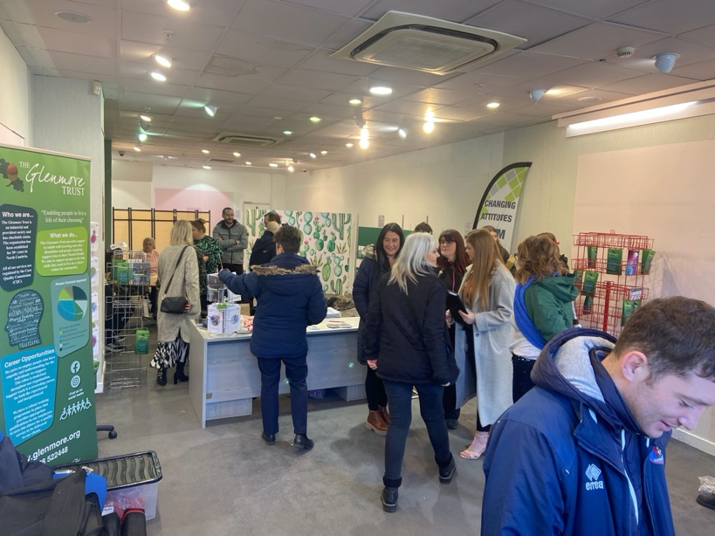
“Comfort the Afflicted and Afflict the Comfortable”
Finley Peter Dunne

Research and why Carlisle needs the CCC hub.

The UK is living in crisis! A cost-of-living crisis, an NHS waiting list crisis, an obesity crisis, a mental and physical wellbeing crisis and increasing rates of suicide crisis. The partnership knows from working with their variety of beneficiaries and from professional strategy meetings/ professional news bulletins that some of the hardest times are yet to come. The partnership felt the need to offer more information support and assistance to those who are falling through the gaps of statutory services to offer clear and friendly support via information in one place at one time for people who needed it. This need was identified through a variety of sources including stakeholders, the public, research, funding trends and professional planning meetings.
The partnership value research and information that is already provided from respected sources. To plan and inform the direction of the project, the partnership researched the following:

The Kings Fund June 2023

“Communities are playing an increasingly important role in improving health, and meeting the wellbeing needs of people locally, highlighted in part, by their role in the response to the Covid-19 pandemic. Integrated care systems (ICSs) need to recognise the role communities can play in improving and sustaining good health, and as part of this they need to seek greater involvement with local voluntary, community, and social enterprise (VCSE) groups at the place and neighbourhood level, where the link local communities is at its strongest.”

C2 Connecting communities 2023

The partnership contacted C2 representatives Clive Bowers and Hazel Stutely to discuss their community model:

“The C2 7-Step Pathway leads to the formation of community led, problem-solving partnerships between local people and providers, creating a health-promoting, self-renewing framework for on-going, lasting improvement. This benefits residents and multiple sectors simultaneously, typically Police, Housing, Health and Education. C2 works by releasing latent strengths and capacity of both residents and service providers, who work together as equals to identify and overcome local barriers to reversing decline”

How many people who request social care actually get it?

CCC studied the trend in social care and the effects of it on our community – although statistics are national, issues remain the same across the country.
In 2021/22, local authorities received 1.98 million requests for support from new clients – 612,000 from working age adults and 1.37 million were from older people. In total, 818,000 people received long-term care (529,000 older people and 289,000 working-age adults). There were also 224,000 episodes of short-term care.
Overall, around 43% of requests for support result in some form of service, a further 26% receive advice or signposting, shockingly 30% receive nothing. (County council, 2023)

DCMS - Wellbeing and Loneliness - Community Life Survey 2020/21
Published 29 July 2021 (Appendix 2 – impact of loneliness)

Although at the outset of the project, loneliness was not initially considered as a specific issue, the partnership recognised the importance of loneliness and its effects on wellbeing. Including the decreasing number of shops and stores on the Highstreet for people to socialise in/ meet friendly faces.

6% of Cumbrians are reported to be lonely, approximately 30,000 in Cumbria, and 6480 in Carlisle. Loneliness is “a subjective, unwelcome feeling of lack or loss of companionship. It happens when we have a mismatch between the quantity and quality of social relationships that we have, and those that we want” (Perlman and Peplau, 1981).

Loneliness and health:
- Loneliness is likely to increase your risk of death by 26% (Holt-Lunstad, 2015)
- Loneliness, living alone and poor social connections are as bad for your health as smoking 15 cigarettes a day. (Holt-Lunstad, 2010)
- Loneliness is worse for you than obesity. (Holt-Lunstad, 2010)

The National Lottery June 2023 Community Research Index - Research highlights
Food banks (42%), supporting older people (35%) and supporting young people (25%) were among the most popular areas chosen by people who intend to volunteer, showing that communities think they understand or recognise where support is most needed and act upon it. Our project would like to see if these topics are relevant for the people we work with.
More people (42%) felt the COVID-19 pandemic had strengthened community spirit than weakened it (18%), demonstrating how we come together to get through times of crisis.
Support with the rising cost of living is one of people’s main priorities for this year. They expect food banks, financial advice charities and housing services to be in demand. “Most also said they’ve already cut their own spending, more than a third (41%) have gone without heating, three in ten people have skipped meals, and a quarter have borrowed money from friends or family.” Advancing our need to promote and publicise that these services are available and can be easily used and accessed.
Community Improvement Districts Pilot Programme

Emerging learning from the first phase of the CID programme
By Julian Dobson, Kate Swade and Kim Graham March 2023 say:

“The pilot programme for Community Improvement Districts (CIDs) has emerged from a continuing need to revitalise traditional high streets and town centres. High streets and town centres have faced arduous challenges in recent years, with the Covid-19 pandemic in 2020- 21 accentuating existing trends such as the increasing shift to online retail and accelerating the demise of traditional department stores.
These trends have exacerbated widening inequalities within communities. But they have also offered opportunities for new ways of creating thriving places, where benefits are shared more equitably. While Business Improvement Districts (BIDs) have been a successful model for involving business communities in local economic development, there is no parallel system enabling residents and community led organisations to participate.
Community led approaches can bring much positive change in terms of town centre regeneration. With this in mind, the first step towards promoting this approach has to be to involve community stakeholders in strategic conversations about the future of town centres. This is what CIDs aim to do: they provide a forum where groups of stakeholders that are wider than usual can discuss and plan the future of their town centre together.”
A Power to Change paper by Ben Stephenson published in 2020 defined Community Improvement Districts as ‘bodies which provide opportunities for community stakeholders to participate in operational and strategic decision-making for their neighbourhoods’. Such organisations would be:
- Non-political, democratic, and inclusive
- Concerned with the economic, social, and environmental development of neighbourhoods
- Open to residents, businesses, and other stakeholders
- Designed to complement other local mechanisms where they exist
- Non-profit distributing bodies
Aims and predicted outcomes:
It was important for the partnership to set clear and achievable objectives for the pilot programme focussing on the need understood from the background research. Partnership meetings were held to discuss and plan these:

CCC aim:
- Improve community access to all third sector services, ultimately relieving the burden on statutory services.
- Improve connectivity between services.
- Improve City Centre services and entice more people into the city.
- Improve community access to physical, mental, and financial support from a non-clinical aspect.
- Increase preventative measures rather than reactive measures.
- Increase advocacy that statutory and third sector partners care about our citizens and can/ will offer support.

Predicted outcomes:

The group carefully considered the predicted outcomes and agreed these at bi-monthly partnership meetings.

- Increased support for our community.
- Increased portfolio of support and referral routes to third sector organisations.
- Improved communication between statutory and TSO.
- Improved communication between statutory and citizens.
- Decrease wellbeing demands.
- Increase advocacy and awareness of the project for further delivery.

A vision of a future aim was to create a larger presence in the city centre when we have understood the needs of our community.

Cost of the pilot project

In order to progress with the project and most importantly secure a venue to become the hub itself, a small collection of funding was secured from the following sources to support the 12-week pilot period.

£5000 from Cumbria County Council
£5000 from Carlisle City Council
£5000 from CHoC
Total: £15000
(Appendix 3 - CCC budget).

This budget was not collected from open funding applications from national or local funders but requested through partnership communication directly with the funding bodies themselves. All parties who supplied funding did so with their own wishes and on the provision that adequate promotion of their generosity was publicised and a report sent to them at the end of the project for evaluation of the service.

This budget is very small for the amount of work undertaken by all 5 partners and the launch of a city centre location with the buildings necessary and legal requirements. Partners agreed that wages for their staff to work the CCC hub, rent, utilities, reporting tools and survey collection aims, legal and professional fees and marketing should be used from this budget. There was also an allocation for the evaluation report to be performed by Julia Clifford of iCan Health and Fitness CIC. No partner entered into this project for any financial gain or for profitability, but rather to support the community and the need presented.

Statistical findings and outcome of the project
Opening duration and visitation level
The CCC hub opened on 1st March 2023 and closed on: 23rd May 2023.The hub was open a total amount of 42 working days and saw 1003 people walk through the doors; an average of 23.8 people a day. (This includes stakeholders and repeat visitors.) The hub was open to the public from Mondays- Thursdays due to the availability of the partnership staff utilising their existing staffing body.
General public stakeholder survey
It was important for the partners to gather information to understand if we had obtained our objectives from the general public, to do this we installed a “viewpoint” © survey machine at the front entrance to the hub and asked as many people as possible after their visit to spend a few moments answering 4 questions. During the pilot period 129 people answered our surveys (13%)
One question asked of the public was “were you given information by the hub to refer yourself into a service that can support you?” 62% of people answered yes to this question, this shows that most visitations received the information they needed to visit another third sector organisation, charity or support organisation. Achieving the CCC aim 1,2 and 4.
Data analysis shows that 48% of the public are unhappy or very unhappy when they walked into the hub and when asked how they felt after a visit to the hub 89% they felt very happy and 8% happy totalling a 98%, with only 2% remaining very unhappy. This is an impressive outcome for our predicted outcome 5 of decreasing wellbeing needs.
The partnership was interested to find out why people were visiting the hub. Based on thew viewpoint© instant feedback, our community showed they needed/ wanted:

Financial support 27%
Mental Health support 20%
Benefit advice 17%
Social support 11%
Wellbeing support 10%
Other 8%
Housing support 4%
Employment support 3%.

The support requested most was for financial support, indicative of the cost-of-living crisis and our confirming our research findings. Our aim to produce a centre that offered “community access to physical, mental, and financial support” (aim 4) seemed to be accurate with the top scoring needs considered. (Appendix 4 – feedback from the public)

General public Case study- Spring 2023:
Note: The person wished to remain anonymous for this case study and has been given a fake name for this testimonial. This case study was written by Lydia Hulme- Carlisle Network- social prescribing link worker.

“Jeanette* visited the hub with her friend and wanted to speak to someone privately about an issue she was having. Staff at the hub quickly ascertained that it would be appropriate to refer her to her GP surgery’s social wellbeing team as Jeanette was withdrawn and didn’t want to share information about her situation in the hub. The Carlisle Social Wellbeing Link Worker (SWLW) for her practice got in touch and it was clear that Jeanette required the support of a female link worker, who saw her in practice within the same week.
Jeanette was in an abusive relationship and needed support to manage her divorce. She also needed to protect both herself and her child. She wasn’t sure if she wanted to leave her home as she was scared she would end up homeless, without childcare support and was concerned for her job security. The SWLW accessed safeguarding support to appropriately manage the case and signposted the patient to a range of support services including:
- The National Domestic Abuse Helpline
- Turn2us
- Women’s Aid
- Shelter
The SWLW also advised her to call 999 if she was in immediate danger and ensured Jeanette had the confidence to do this if she needed to. At this stage, Jeanette decided to take a ‘watch and wait’ approach. She would stay in her home and use the signposting tools if she felt she needed them.
The situation worsened, resulting in Jeanette needing to action some support. Within 14 days of her initial contact with the hub, Jeanette and her SWLW had worked together to get her a self-contained refuge apartment for her and her child, had ensured Jeanette’s car had an up-to-date MOT as it had lapsed, completed a welfare check, engaged with refugee UK, re-organised Jeanette’s work patterns to fit around childcare availability and claimed child benefit in her name, instead of her husbands. She is now working alongside a support worker to ensure her ongoing safety and financial stability.”
A quote from Jeanette: “Walking into the hub that day and meeting you changed my life. I felt like I was drawn to the hub and now I’ve got a different life ahead of me.’’

Professional stakeholder survey

Across the project, the CCC hub worked with 63 stakeholders, at the end of the project the partnership asked them to fill out an online survey of their feedback about the hub activities and their thoughts on what was needed. 41% of stakeholders filled out the survey.

The Results show that:

95% of stakeholder organisations had a presence in the hub, actively showing that we took the documents and publicity provided by stakeholders and presented it to the partnership’s best ability.
The stakeholders confirmed that 70% their organisations did benefit from accessing the hub to discover what other providers offered.
85% felt that the CCC partnership adequately showcased the VCSE in Carlisle. With a further 85% stating that they think the CCC hub should be continued for the benefit of the community. These results show that the partnership achieved their predicted outcomes 2,3, 4 and 6- ultimately increasing communication between third sector services themselves and the public.

The partnership asked for constructive feedback to improve the provision in the future. 75% answered this request with comments such as:

1) “Create a ‘coffee shop’ relaxed environment to increase confidence for those walking in by removing desks and other barriers to engagement”

2) “Have a private and confidential space available to talk to those who need it”

3) “Improved signage in a more permanent set-up. Perhaps keep the doors open to invite people in”

4) “Secure Wi-Fi for staff working on the premises to use”.

By asking for this feedback from the professional stakeholders we were able to identify what they needed from the hub alongside the public influencing some of our decision for any future work justifying our aims 1 and 6 of providing a space for improved community access and advocacy for all third sector services.

Social prescribing/ social link workers and Carlisle PCN access in the city centre

A consideration the partnership had not made in the planning phase of the project was that the Carlisle PCN social prescribers could have access to the hub to deliver their appointments or first face to face meet ups in a mutually relaxed environment, that would be easily accessible via transport links and in the local easily accessible vicinity of their patients’ homes.
The partnership engaged with the Carlisle PCN Social Wellbeing team. Three Social Wellbeing Link Workers from Carlisle Primary Care Network’s Social Wellbeing team supported the initiative by attending the hub for a visitation and then agreeing to work from the hub in the later weeks of the project; meeting members of the public and signposting directly into services where appropriate.
The outcome of this place-based work was outstanding with patients being seen from the hub weekly. One social prescriber said: “a great outcome was that the team provided ongoing support for two people who they met in the hub, who took on formal Social Prescribing appointments to develop their current wellbeing goals.” The partnership believes these people would not have reached out to their social prescriber if it hadn’t been for a visit to the hub.
The Social Prescribing team “welcomes a more permanent wellbeing hub in the city and would like to be a part of any engagement and support in setting this up to support our patients in the community.”

A quote from a social wellbeing patient:

“‘I couldn’t have got to my appointment with you at the GP surgery on any other day. Having you here fits around my new activities and I really like the option to not see you at the doctors”

If we consider that “a recent study estimated that, in 2021/22, the average 9-minute GP face-to-face consultation costs £42”, and the CCC pilot project cost £15000 and saw 1003 people, that crudely works out at just £14.95 per person. This type of support could save the NHS/ statutory services £27.05 per patient and possibly eliminate the need for onward referral from the doctor to patient in the surgery itself which costs more time and money post appointment.
(Appendix 5 – feedback from stakeholders)

Conclusion

All partners working on this project agreed at the final meeting of the pilot stage that the project was successful and that all wished to continue the project into a further stage. This would have to include sourcing larger more sustainable funding, a location that was suitable for the venue either long or short term. Or perhaps even moving the venue between City areas. The need to secure a project lead was evident and a team member to work from the hub full time to ensure the safe and good practice of its daily opening.

Based on the findings from the research and professional stakeholders surveys the partnership can conclude that the CCC hub is a cost effective way to have a drop in hub for wellbeing and social services in the city centre. With the potential to save statutory services £27+ per patient if delivered in conjunction with the social prescribing team. The partnership and PCN teams understand that a collaborative approach is essential to make systemic change in our community and are committed to that change.

The findings from the public stakeholders indicate that people feel happier when they visit the hub and receive information in the moment to be able to self-refer into other services with 98% of people feeling happier post visit and huge achievement to our city’s wellbeing needs.
The CCC hub should maintain an offer of financial support and mental health support, as these are the 2 most important issues currently affecting people’s lives in the city.

The partnership are committed to Phase II and have the backing from professional stakeholders that this needs to happen imminently to keep up the momentum with 85% of 63 stakeholders suggesting the project continue.

Recommendations

The partnership has learned and listened to all community stakeholders and would make the following suggestions for any future work:

- Secure further sustainable funding for at least 3 years which can be used to fund a premises, staffing costs, partnership planning and project management and longevity funding.

- Approach higher level PCN staff and statutory leaders to discuss an approach where social prescribers can be actively involved in the delivery of sessions at the hub or have a private space to see patients in a City Centre location. This could also be a way of introducing a traded income element to the project by hiring the room to the NHS.

- A consideration of making the fact that financial support is available on advertising and marketing material may be beneficial based on the community need. A suggestion could be to change the hubs service tag line to: Wellbeing, financial and social support hub. With an allowance made more financial services to share the space, present to the public and be evident at point of referral.

The partnership will continue their efforts to support members of the community through the creation of a long-term hub and would like to thank all stakeholders professional and public for visiting the hub during its pilot phase.

References
Author unknown, The Kings Fund. June 2023. https://www.kingsfund.org.uk

Author Unknown, DCMS - Wellbeing and Loneliness - Community Life Survey 2020/21.Published 29 July 2021
Author unknown, The National Lottery. June 2023. Community Research Index - Research highlights. Sourced online
Bowers. C, and Stutely. H, C2 Connecting communities. April 2023 In person communication.

Cumbria County Council, website submission found online, June 2023
Dobson. J, Swade. K, Graham. K, Power to change, https://www.highstreetstaskforce.org.uk/resources/details/?id=047b5f1d-ae19-4872-a02f-392bcfe78fe3, 4 April 2023
Dunne. F.A, syndicated newspaper column in 1902, found online

Holt-Lunstad J, Smith TB, Baker M, Harris T, Stephenson D. Loneliness and social isolation as risk factors for mortality: a meta-analytic review. Perspect Psychol Sci. 2015

Perlman and Peplau, Office of national statistics.1981https://www.ons.gov.uk/peoplepopulationandcommunity/wellbeing/methodologies/measuringlonelinessguidanceforuseofthenationalindicatorsonsurveys. Found online in June 2023
Appendix

Appendix 1- list of stakeholders

- ACTIVE CUMBRIA
- PHX TRAINING
- SOCIAL PRESCRIBERS
- HAWCS
- TULLIE HOUSE
- SPIRAL
- RAMBLERS WELLBEING WALKS
- WE ARE UNDEFEATABLE
- PEOPLE FIRST
- CHRYSALIS
- LAURIE BREWIS TRUST
- MENCAP
- DWP
- FOODBANK CARLISLE
- 108 MEALBANK
- BRAMPTON COMMUNITY FOODBANK
- CORNERSTONE FOODBANK
- ST BARNABAS FOODBANK
- CARLISLE KEY FOODBANK
- COMMUNITY HELP GROUP AFFORDABLE FOOD HUB
- CARER SUPPORT
- CORNERSTONE
- CURROCK HOUSE COMMUNITY CENTRE
- THE LOOKOUT COMMUNITY HUB
- ST BARNABAS AND ST LUKES
- HARRABY COMMUNITY CENTRE
- HAPPY MUMS
- COST OF LIVING ADVICE (CARLISLE CITY COUNCIL)
- FAMILY ACTION
- CACE
- CUMBRIA LAW CENTRE
- HOMELESSNESS PREVENTION AND ACCOMODATION SERVICE
- DISABILITY ASSOCIATEION CARLISLE EDEN (DaCE)
- RECOVERY STEPS CUMBRIA
- SAFETY NET
- BLUE SKY TRUST
- THE SALVATION ARMY
- VINEYARD CHURCH
- HEBRON CHURCH
- ST PAUL’S ELIM COMMUNITY CHURCH
- RESTORE ANGLICAN COMMUNITY CHURCH
- ST VINCENT DE PAUL SOCIETY
- CHURCHES TOGETHER IN CARLISLE DISTRICT
- BEREAVEMENT SUPPORT
- SAMARITANS CARLISLE
- CRUSE BEREAVEMENT CUMBRIA
- EDEN VALLEY HOSPICE
- EVERY MIND MATTERS
- EVERY LIFE MATTERS
- CARLISLE STROKE CLUB
- WELL SUITED CIC
- REDCROSS
- CHOC
- THE GLENMORE TRUST
- AGE UK CARLISLE AND EDEN
- REBUILD CIC
- CARLISLE AND EDEN MIND
- PRISM ARTS
- STEP FORWARD
- HSBC
- GROWING WELL
- CNTW
- CARLISLE UNITED

Appendix 2- Official Statistics
DCMS - Wellbeing and Loneliness - Community Life Survey 2020/21

Published 29 July 2021
Overall in 2020/21:
- 6% of respondents (approximately 3 million people in England) said they feel lonely often or always. This is the same as in 2018/19 and 2019/20.
- 20% of respondents (approximately 9 million people in England) said they never feel lonely, similar to 2019/20 (21%)
- A composite loneliness score was produced combining three indirect loneliness measures. A high score indicating loneliness was reported for 9% of respondents, approximately 4 million people in England; a similar proportion to 2019/20.
- 7% of respondents who didn’t formally volunteer reported being lonely often/always. This was higher than those that did formally volunteer (4%). These figures did not vary from 2019/20.
- Men were more likely than women to say that they never felt lonely (24% compared with 17%). The number of respondents who reported their gender as ‘other’ was too small and so no analysis has been conducted here to avoid being disclosive.
- There were differences by age group in feelings of loneliness, with people aged 16-24 more likely to say they feel lonely often/always (11%) than every other age group (3-7%).

Figure 2.4 - How often respondents feel lonely by age group, 2020/21
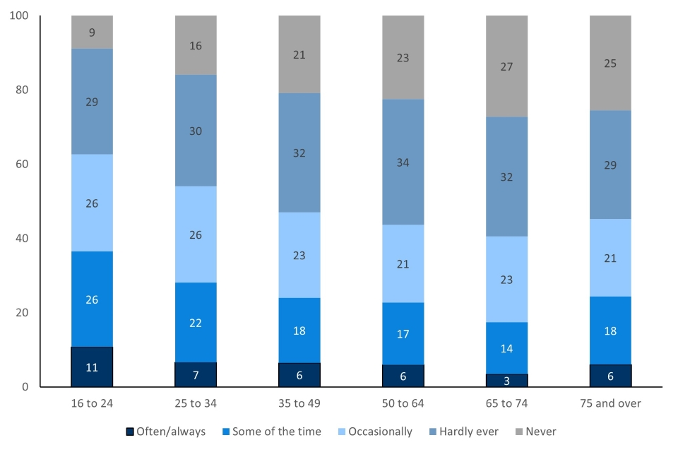

- People with a limiting long-term illness or disability were more likely to say they felt lonely often/always than those without (15% compared with 4%) and less likely to say they never felt lonely (12% compared with 22%).
- Those living in the most deprived areas were more likely to feel lonely often/always than those living in the least deprived areas (10% compared with 4%).
- No variability was seen between the different ethnic groups, region or rural/urban categories.
As was the case in 2019/20 it is interesting to consider these demographic estimates alongside those in Chapter 1 of the Community Life Survey, Identity and Social Networks. Though women reported higher levels of loneliness, they were also more likely to have regular contact with family and friends across a range of communication methods, and more likely to agree that they have support networks.
People with a long-term limiting illness or disability were less likely to feel they had support networks to rely on when they needed them, and this may be related to their increased feelings of loneliness. The same was true in 2019/20, as was reported. Our estimates show that 16–24-year-olds report the highest levels of loneliness, though also report having robust support networks. While there were some differences in methods of communication between age groups, it is unclear whether this is related to the differences in experiences of loneliness between age groups.

Appendix 3 - CCC Budget
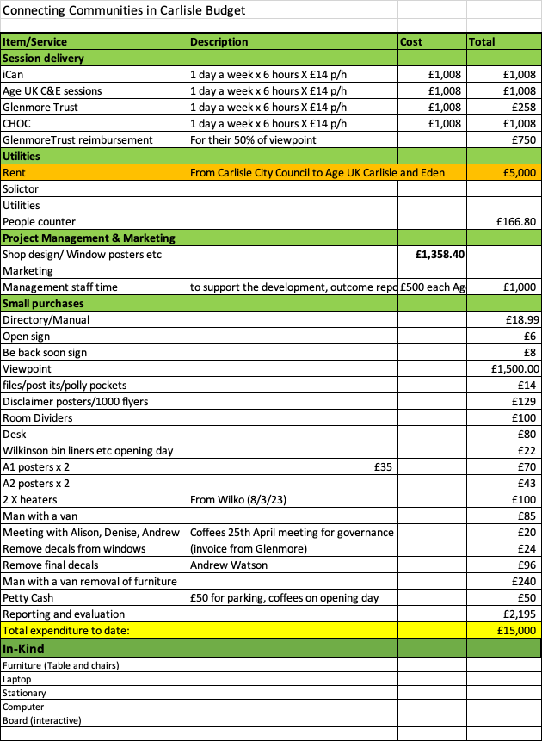
Appendix 4 - Public feedback

- Really informative and directed me to service
- One to one access one stop information base
- A hub with all the information and a city centre community cafe
- Transport
- Day care Respite transport to services
- We think this space will highlight the gaps
- This facility helps bridge gaps of helping raise awareness in the community
- Internet services to get more information
- There are lots of organisations but a lot of the time there’s no joined-up thinking so this needs to improve
- I’m lonely
- Men’s mental health support
- Young people’s help
- I don’t hear enough about services
- In home support, an independent living support framework.
- Not sure
- Men’s support
- There needs to be more information available to peopl
- More empathetic services
- More women’s health facilities more help for offenders into work or leisure facilities
- Hear me
- Big gaps everywhere. Underfunding by the government
- Mental health
- It was very informative
- Very good
- Who knew so much was happening in our city
- Amazing, two lovely ladies
- Lots of information. Welcoming
- Very Good
- Yes, help for ex-offenders and men’s mental health
- First time I have had something for nothing and I’m 80
- Not knowing who to contact
- Not knowing which services can help me with what
- Great information
- More advisers at any one time would be great
- Lack of info to help when you have diabetes on a budget
- No gaps
- I need help
- Women’s health checks
- After talking today here, I feel a lot better and more assured that help is here. Places like this must remain and be fully supported to ensure the well-being of local people.
- Social wellbeing prescribing provision
- Help for pensioners
- Not knowing who to ask
- Availability outside normal working hours
- I need more support from communities around me and not medicine
- I think for young people, in particular young guys that feel isolated
- I would like to see more leaflets and support for people of different race, but the service is good and quite new. it’s nice to get help
- Received some really good advice and leaflets on different services I can access.
- Are there any new activities for the elderly
- Free legal advice
- Open at weekends
- Asylum support

Appendix 5-Feedback from stakeholders

Stakeholder case study:
“I think CC has benefited CHOC as the people we have seen (walk-ins) have not been aware CHOC are involved with mental health and it’s been a fab opportunity to inform them of what we do. Also, it has helped get people on the SMI register to have a base in town to deliver the health checks and to offer the patients advice and support from the other services advertised.
I feel the project has been really good as the people we have seen have been very grateful for the advice they have been given. The main comment we have heard is “I didn`t realise all these services were available”

Been great to be involved in such a good project”

We need to involve the police more as they are the heart of the community
- Was it the right location?
- Was the shop front image off putting?
- The fact the door was closed during the colder months?
- Not enough time to know that we were there?
- Funding to deliver regular drop-in sessions within a hub setting.
- Possible outdoor presence as this may increase the footfall?
- Longer opening hours and alternative access routes.
- I think it has been a brilliant idea but maybe if you had a stand outside the shop/venue or someone with leaflets to coax people in you'd get even more visitors? Just a thought.
- Cumberland citizens would benefit from coordination of its resources and the removal of duplication, the landscape is too confusing. This morning I learned about CC employed Social Prescribers, this is in addition to NHS Link Workers; we also have community development officers and a range of direct delivery support roles at CVS.... the list goes on. All of this is firmly rooted in the VCSE and this is where it belongs. The hub could be very effective if all parties referring into the sector had a presence there, or even better, if the VCSE were commissioned to coordinate the work of these statutory roles with the incentive to remove financial duplication and reinvest the saving into the sector itself. There are too many travel agents and not enough holidays!
- Cumberland Authority to promote all services
- FREE taster sessions
- Wherever possible - ALL organisations to be involved in manning the premises to share responsibility
- Have drop-in clinics etc to attract more individuals
- If shop premises were used again - leave windows clear to encourage more people to pop in
- In future, I think that there should be a role for a Co-Ordinator who can then liaise with all partners and third sector reps. They could also source funding to support specific activities etc.
- Personally, I appreciated the support from all partners involved. This project would not have succeeded without hard work from key people. I'm aware that the communities of Carlisle have benefitted from this free service and I'm confident that the hub would have a role in the future
- Brilliant initiative which should definitely continue and I hope grow!
- No improvements as such but would be great if we had another opportunity for this, to ensure it is local, e.g (Carlisle city centre)
- A great project the only challenge was on the days we were there we didn`t have many people in, just not sure what could improve this? Maybe a different location as a lot of people can`t get into town. Maybe a mobile option would be better as this would attract more people in different areas?
- a wider involvement and ownership from other organizations would be good, and possibly having an existing city Centre multi-function space as a venue, where people may access a service but be able to pick up more information from connecting communities
- A better layout in the unit. A better layout in the unit.
It looked a bit ad hoc / temporary when I was in so didn't have a welcoming feel to it.
- I have already previously mentioned this but I do not think the shop frontage itself was particularly inviting to people. They could not see inside which I think could perhaps of prevented them choosing to go in (really hope I am wrong).
- We loaned new equipment to the centre and it was returned in a managed and not new bag. We are now needing to source a new one. We understand that things could have got mixed up fairly easily.
- Larger site, with 6 day a week access and workshop space. Ideally manned by a jointly funded front of house team that are able to signpost appropriately rather than relying on already busy and under resourced organisations
- This is a great idea that needs to be supported by statutory organisations who benefit so much from what the 3rd sector offers our communities.

- To remove at least one of the window stickers. The 2 windows and doors being covered often made the hub look closed.

- Sometimes the hub was closed during its advertised opening hours. Try and adhere to the advertised opening hours, this will help develop trust of people.

- To redecorate the hub. It looked a bit sad and it would be great if it could be made to feel more welcoming.

- I thought this, the hub, was a great idea and I had said for years that Carlisle is missing something like this.
The City Centre location was excellent as the City Centre is accessible to many people and is on almost all bus routes.
Each time I was in the hub the staff were very friendly and knowledgeable and I witnessed them offering great advice and support to people.
It would be fantastic to see hub continue and for more organisations to support it.
Well done to everyone involved in the creation and delivery of the hub.

- It's hard to give specifics on what exactly would need to be improved to make the provision better. I think that every organisation that contributed agreed that it was important and that it was a great way of networking with each other, but that the format it took maybe wasn't right for best promoting activities and services and engaging with those most in need. But it was the right step to do to pilot that model.

- You showcased what you were aware of/had contacts for at the time. As you know we had a few follow-up enquiries to the email we sent out promoting the CCC asking why services they personally were involved with weren't part of it. We got them represented which was great. Not sure how it would have been possible to promote the opportunity further in advance, it’s a tricky one!

- More staff needed to offer immediate advice

- Yes, 2 useful contacts made, and it gave our social work student a chance to see what else is happening locally

