End of grant report

National Lottery Community Fund- iCan Health and Fitness CIC/ iCan wellbeing Group CIO

Social and financial sustainability for iCan
Project number: 20207448

CONTENTS

Grant summary. 2

The story of our project. 2
Professional development 2
Restructure of the gym 3
SROI 4
Business planning 5
Business plan 5
Financial forecast 6
Organisational structure 6

How we included people in our project. 7
The differences we are making. 8

Lessons learned. 9

How we are changing what we do. 9
Financial statements. 10

Attached documents.
Appendix 1- Business mentor meeting notes
Appendix 2- Gym restructure presentation
Appendix 3- SROI report
Appendix 4- 5-year Business plan
Appendix 5- Financial forecast
Appendix 6- University Thesis- organisational structure
Appendix 7- Receipts

Grant summary
The project was designed to support iCan’s future 5-year plan of social and financial sustainability. The grant was to be spent on business development and strategic planning, funding expert specialist support and a percentage of Lisa Bridgewater’s (senior leader) salary enabling the following to be created:
- A new 5-year business plan for sustainability
- A new 5-year financial forecast
- Scoping the market/ market research/ Collaboration potential and partnership working opportunities.
- Organisational structure reformation
- A new SROI for 2022.
- Consideration would also be taken to work on a critical and reflexive study of the local Third sector opportunities available and where iCan might consider changing its legal status to aid the aim of social and financial sustainability.
The story of our project

This project has revolutionised the way that iCan is working from 2023-2028. Through a mixture of reflective practice and thought provoking learning we have been able to set a plan in motion to not only protect iCan membership and continue running classes and services that they love but also plan for the future and dedicate our time to doing what we know, what we are good at and what service users need whilst creating sustainability both financially and socially.

Professional development:
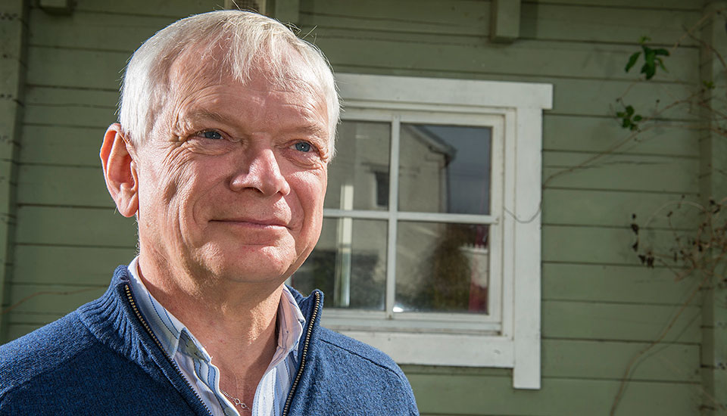
The journey started with professional development. Lisa was quick to find a business mentor who could work with her to focus on both the financial stability of iCan and business planning, but also understand how to get the most out of the way she works, understand her passions and expertise, and improve her efforts as a manager of the workforce and members.

Lisa was advised by Cumbria Chamber of Commerce to employ the services of Alan Smithson of ‘A S Business and technical solutions Limited’.
From initial meetings with Alan, the pair devised a plan of action to meet monthly, moving towards the end goal of a full business plan and financial forecast after 6 months of meetings.
During the meetings they would discuss what needed to be achieved, any tasks to follow up on for the following meeting on both sides, any personal circumstances that might affect good decision making and how to deal with those and projections of what the future of iCan should look like.
After each meeting Alan provided meeting notes (Appendix 1).

Throughout the 6 months of meetings with Alan, Lisa felt empowered and clear, with the long-term vision for iCan and how she should be leading the workforce to understand the implement the company objectives.
Lisa also learnt about herself. Understanding her own strengths and weaknesses and that of her team/ other senior leaders and how we should utilise those.
An unexpected lesson that came from this work was for Lisa to understand the importance of allowing time for reflection, concentration, planning and consideration. Prior to this reflective practice, Lisa would be forced to jump from one task, meeting, or event to another without time for consideration or even a lunch break to reflect. A critical change needed to be made to implement time for reflective practice and Lisa promised to not only practice this but prioritise it. Lisa now blocks out time in her diary for reflective practice, this could be a few minutes before a meeting to configure her thoughts or sometimes whole days to get pieces of work done (such as this report). This attitude is changing the way iCan works- allowing more concise, consideration into the way the staff work, the decisions that are made and how future aims are carefully considered in each new project innovation or conversation without rushing into important decisions. Lisa would like to continue with a business mentor, if possible, in the future.

Restructure of the gym:
From early on in the project it was evident if iCan were to continue, they needed to make changes to the way they brought in their traded income. Sadly, at that point the gym aspect of iCan was failing financially (yet could be one of the bigger income generators) after
the effects of COVID 19 and Cost of living crisis. Sensibly one could have considered closing the gym, however many stakeholders and our business mentors agreed it needed saving to protect the brand name, our reputation and our members who use it regularly. This meant a critical analysis of the gym service and the way it operated. Followed by a restructure of its service, its operations, its staffing, and its reliance on other parts of the organisation.
Lisa worked alongside her business mentor but also asked for support and guidance from another charity leader with vast experience in the industry and strategic planning- Alison Ambrose (CEO of Age UK Carlisle and Eden). Together the advisors challenged Lisa’s analysis of the gym service and provoked thought for how cost-based changes could occur. Lisa worked on a restructure presentation (Appendix 2) after consulting members, staff, senior leaders consulting with the board of Directors for consent to implement the plan.
Two factors have been critical to the effectiveness of the restructure: A dedicated time frame/ mission for the project with set targets, implementation, and regular reviews. Second, through cooperation and partnership with the stakeholders the project was effective in its implementation, and stakeholders are happy with the changes creating social sustainability. In 2023 we are seeing a steady rise in income generation and the gym finances are now breaking even.
Social return on investment evaluation (SROI):
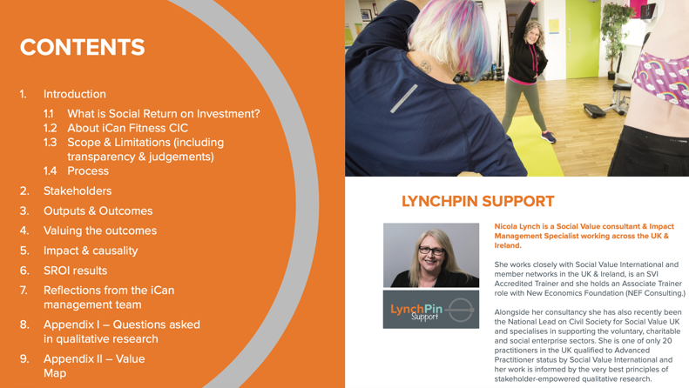
In 2023 Lisa and senior leaders chose to employ the services of Nicola Lynch from LynchPinn support Ltd to conduct a full SROI evaluation on the fitness and wellbeing services iCan offers. The SROI report would highlight where the services were doing well, where they could improve and provide a social
return on investment value to the service for the year 2022-2023.
This work would enable iCan to view their service from an outside perspective from its professional stakeholders to its membership body with professional analysis.
The process included providing Nicola with all evaluative documents, case studies, testimonials, service user numbers and reports of the service from March 2022- March 2023. She then conducted a series of interviews with service users both in person and online. She also conducted similar interviews with our collaborators, board, and stakeholders. She interviewed our staff and leadership to also gain their thoughts on the organisations and our practices.
After 2-3 months of analysis, she presented us with the SROI report (Appendix 3) and the SROI valuation of £6.13:1. The figure itself was pleasing to us and we appreciated the reserved advice of this figure. The valuation will now help us to show how our work can save the likes of other charitable and statutory services such as the Council and NHS money, if they use our service for the benefit of their clients or patients. This proves critical in contract tender meetings.
The report itself was vital to reflect on how we work, what our stakeholders want from iCan and where we can improve. The overall conclusion was that iCan tries a little too hard and wants to help a huge variety of people. A consideration for sustainability would be that we pause our innovative efforts and focus on what we do well for a while, building up those services to financial sustainability before embarking on new.
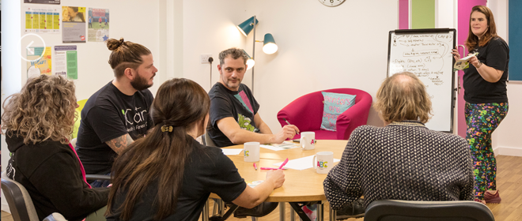
With this in mind our leadership and staff came together in a meeting to decide on our next 5-year goals and aims. The conclusion was to focus on “doing what we do… but better”, preparing for the future in year 2-3 and the 4th and 5^{th.}
year social and financial security (differing from sustainability and reflecting the current economic climate). Having a clear mission and goals across our staffing team enables the whole team to understand the strategic thoughts create achievable targets to get us there.

Business planning:
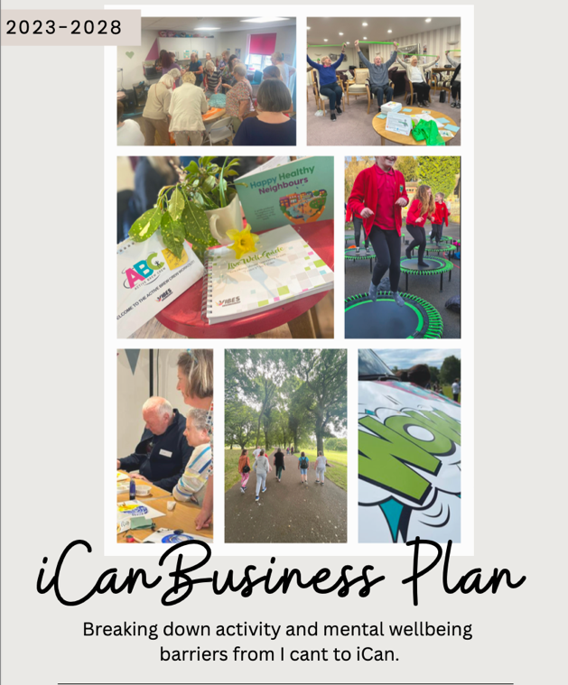
During this time Lisa embarked on writing three new strategic documents.

- Business plan; The first is a new 5-year business plan (Appendix 4) for the operations of the business, our mission, and goals until 2023.
At a recent staff meeting this was shown to the staff who agree with the direction of the piece and are pleased to know this piece of work has been performed for their knowledge, transparency, and clarity to work towards. This has also been shown to the board and they are currently looking further into the document to make sure they agree before signing it off.
This piece of work had many adaptations and took about half a year to produce to its final edit, changes to our practice and operations meant almost weekly changes in the document and Lisa had to understand there will never be a final document for these reasons and reflecting both operational, economical, and environmental change. However, the latest copy will provide a true reflection of our current work, identify where we aim to go in the next few years. The plan features our current operations, our vision and mission, our 3 major aims for the next 5 years and a detailed guidance of how to achieve these. It also includes our aspirations for the future, financial forecasting, market analysis, SWOTs of both the operations and our staffing structure and recommendations for future finance sourcing. This document can now be used to approach funders, benefactors, and our stakeholders.
2)Financial forecasting; The second is a full financial forecast (Appendix 5) for the next 5 years. Akin to the business plan we would expect this document to change with ongoing PESTLE analysis, however it does give us a clear picture of the financial assumptions the organisation can make to date. It has been particularly effective to highlight when and how we need to look at bringing in substantially more income to help the organisation thrive and survive. For example, one can see that until March 2024 iCan is fairly confident with its project income and traded income however by April 2024 most of our current funded projects will have come to an end and we should be proactive now to obtain more. It also highlights the effects of national living wage changes, interest rates and inflation and how these will have a negative effect on the core finances so we must prepare for those eventualities.
This is the first time iCan has been able to prepare financially for the future and use such tools to monitor its progress, P+L expectations and drive the company to filling those funding gaps sufficiently whilst not taking on too much work we don’t need before a period of essential need.
The forecast has been shared with senior staff and the board for consideration and is now used daily by the senior staffing team to implement ideas, creation of funds and highlight exactly how much needs to be made to cover costs.
It is also exciting to use as a planning tool to see the effects that larger sums of income would have on the organisation- utilising the flexible forecasting slide to play with projections. This enables the team to innovate proactively. A true example of this, is the idea that we need a fitness manager, we know that would cost £30,000+ per annum so how can we make that achievable. We could increase X more membership, bring in X more income from the outreach projects or look for X amount of funding.
We were also asked by our landlords to consider a rental increase for our current property, which right now we would struggle to afford but using the forecasting tool we were able to see how much we could afford and even consider other premises options including conversations with the council over peppercorn rates etc.
In order to create the financial forecast effectively, Lisa sought support from both her business mentor and our accountants Dodd and Co. They helped Lisa to learn about correct financial forecasting, give ideas for a template, gave advise when working through the document precising and answering any questions Lisa had regarding the creation of the document. We hired their services to do this.

3)University Thesis- During this project Lisa completed an MBA in senior business leadership in which she had to write a 15,000 word Thesis on a topic relating to her organisation. With this project in mind Lisa was able to utilise her university knowledge and, on the job, learning to write the Thesis on the differences between organisational structures and if converting to a CIO may be more beneficial to iCan. (Appendix 6). After lengthy analysis, it was decided that this could be an effective approach for iCan, the conclusion highlights that:
“The results indicate that a change of legal status from CIC to a charity, CIO or MOS might be a viable option for the CICs finances as those organisations benefit from more access to grant funding in the current market and more accessibility to partnership working with local TSO leaders and collaborators. Suggesting that a company with charitable aims and status would be more trusted and appealing to work with on projects for social good causes.”
“Findings also show that the beneficiaries of such organisations could have viable opinion when considering legal status change, offering advice to the enterprise they use and an insider perspective of how their organisation (as they value it as theirs) should operate. The preconceived ideas that members opinions should not be counted or that beneficiaries would not understand the concept was lightly disproved in this small research study, with members of iCan showing their willingness to interact with legal status discussion.”

How we included people in our project

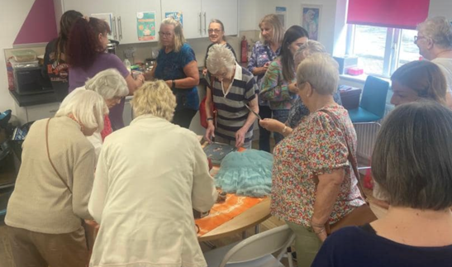
Throughout this project Lisa found it beneficial to include different groups of people in the project process and to review her changes, projections, and possibilities. These people ranged from stakeholder professionals to service users and everyone’s points were justified and valid.

Lisa utilised the support of professionals to act as an advisory panel and data experts including:
- CEOs of other organisations for practice analysis and advice
- SROI professionals for reporting and evaluative purposes
- Business mentors both paid and voluntary to advice and guide on the direction of the business, challenge leadership decisions and guide senior leadership health, wellbeing, and best practice.
- The board to contribute to and decide on the direction of the work taking place.

Lisa also explored the importance of asking service users their thoughts, opinions and for customer feedback. This was integral to the creation of the 5-year plan and sustainability planning but also enabled the service users to feel valued as a significant part of the iCan decision making team.
Members were sent surveys, personally interviewed, asked questions both formally and casually and showed preparations and workings in steering group meetings.

iCan also made a conscious effort to talk to fellow community service charities and TSO’s. One of our senior leaders has a role of PR and spends 40% of their working week at meetings with likeminded professionals discussing city and county health and wellbeing strategies, teaming up with collaborative partners to create new incentives and present ideas for collaborative funding bids and pieces of work to be performed.
We have secured partnership working with the following companies during this year including:
- Age UK Carlisle and Eden for social activities, supporting those over 60, digital inclusion and Dementia support.
- Glenmore trust- for mental wellbeing in adults, adult day services and learning disabilities.
- The Laurie Brewis Trust- working together to support young people aged 18-30 with the transition from child to adult services through wellbeing activities.
- Mind/ safety net- Mental health for children and adults
- Mencap- working together to support LD patients waiting for elective surgery.
- Happy mums’ foundation- maternal mental health
- Offload- men’s mental health

We have also been included in new strategic partnerships such as the WCMHP, LLMHP, NHS foundation trust disease prevention, caring for carers, Carlisle community resilience programme, Suicide awareness in mental health.

To create sustainability for the organisation we have also started working with the NHS and local companies to secure contracts including:
- An NHS 3 year preparing well programme.
- Cumberland building society mental health provision.
- Carlisle United mental health provision
- University of Cumbria student mental health and wellbeing provision,
- Young Farmers association mental health provision.
These contacts and opportunities have been formulated through endless meetings, discussions and showcases of our work and we are proud of how we are reaching a huge number of stakeholders to inspire and share our work with.

The differences we are making.
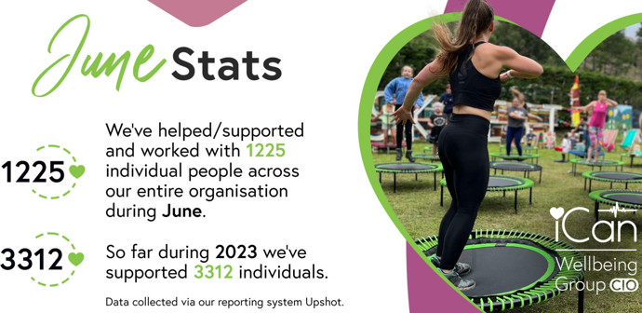
iCan is now reaching on average 1000 people per month and on target to reach 6000 individuals per year. These people range in ages from 7 to 100 and we work with them in different sections of the organisation. We may

see these people on a one-off occurrence, or we may work with them a weekly or even.
daily basis- with the aim of supporting their mental health and wellbeing and prevention of cases getting worse. We are seeing huge differences in our service users with breaking down those barriers to living well and encouraging healthier choices and long term physcoeducational change.

Internally, thanks to this funding we are making changes in our best practice, the way our teams work and our vision for the future.
This year of sustainability consideration has dramatically changed how we (senior leadership) guide, inspire and propel our team to excel in their individual work but also for the brand long term. We have been able to consider their thoughts and skills when strategically planning our 5 year goals and ambitions. We now host monthly staff meetings with the whole organisation where we discuss their own mental health, their progress, any concerns but also discuss the 5-year plan and how we are or can make that achievable. Team members say this has inspired them and clarified what they are all working towards and brings synergy to the brand.

Our leadership team have learnt from previous experience and are now dedicated to making the 5 years plan a success through careful consideration for the projects they tender for, the communications they have with stakeholders, the time they take for meetings and making sure everything links back to the mission of the organisation. They have also learnt the importance of reflection and taking time to make decisions that will affect the direction of their own work of that of the wider brand. This enables good practice to be shown to the staff, the service users, and the collaborators we work with.

Lessons learned.

Throughout this process and year of reflection and planning iCan has learnt about its true direction and how to make that achievable.

If the year were to be repeated again Lisa would make consideration for how much time stakeholder and collaborator meetings would take and plan how many she would reasonably attend without neglecting her main duties. Meetings tend to take 2 hours with at least 15 minutes preparation time before and 30 minutes catch up and plan after. This is a large % of the working day and Lisa must make sure she plans for this and also refuses the appointment when more pressing matters or tasks should take priority.

Lisa has also found the benefit of having a business advisor crucial to her own professional development, it has not only improved her professional knowledge but also kept her motivated, operating change at suitable times and managing her own thoughts.

How we are changing what we do.
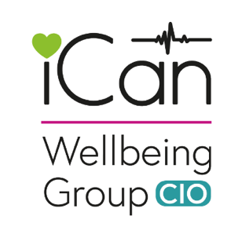
We have now successfully applied and been granted CIO status, converting us from a CIC to a charitable incorporated organisation with a gold standard charity excellence award which is something to be very proud.

of. We hope this change will give us further respect in the TSO communication groups of Cumbria, give us a more trusted name when it comes to securing contracts and tenders from larger organisations and allow us to reach up to 63% more funding opportunities from grants nationally and locally.
The change to CIO has been viewed in a positive light from all stakeholders including professional collaborators, service users and our staffing team.

We have regular team meetings to discuss our progress, our direction, and our financial projections this informs them of our current progress as a brand and also inspires their direction for the future.

We are actively sourcing direct contracts rather than relying on funding bids to produce sustainability. Our traded income sources have also been reviewed and we have started charging a membership joining fees (when it’s appropriate) selling our classes for £1 more than before, selling merchandise and pushing our lottery and other funding incentives to create more income sustainably.
We have also been able to use this approach in the other areas of our business including staff incentives to create further sales such as motivating our Wheels of wellness team to create bookings making x amount of income, if they do by the next calendar year, they will receive a monitory bonus. These incentives are working well for the team’s motivation and willingness to commit to hard work for future reward!

Our commitment to change across the brand is evident and we are excited to see our next few years progressing in line with the 5-year plan and financial projections chart.

Financial statements

The project was allocated a total grant of £26,800. All the money was spent during the allocated period of October 2022- end September 2023.

 | £26800
Budget Breakdown
Senior leadership wage allocation | £20,000
SROI evaluation | £5000
Business mentor and financial forecasting support | £1800

There are no differences or alterations in budget to report. Receipts included (Appendix 7)

