COMPLAINTS PROCEDURE

Date performed: April 2024
To be reviewed: April 2025

Please note this document is available on request in alternative formats including:

- Large font
- Audio recording

Please contact

Lisa Bridgewater
iCan Wellbeing Group CIO
Unit 18 The Maltings
Bridge street
Carlisle
Cumbria
CA2 5SR

Tel: 01228 819101

Mobile: 07818408747

Email: lisa@icanwellbeing.co.uk
Website: www.icanwellbeing.co.uk

- Introduction

We are committed to providing a high-quality service to all our customers, who are registered to use our services. When something goes wrong, we need you to tell us about it. This will allow us to put things right for you and to help improve our service for others in the future.

- Making a complaint

We aim to handle complaints quickly, effectively and in a fair and honest way. We take all complaints seriously and use valuable information from investigating to help us improve our service. We treat all complaints in confidence.

- How you can make a complaint

You can complain by sending an email to us at lisa@icanwellbeing.co.uk or you can send a written complaint by post to 17 & 18 The Maltings, Bridge Street, Carlisle CA2 5SR. Alternatively you can telephone us on 01228 819101 but please be aware we may, where appropriate, ask you to provide further details in writing.

- How we handle complaints

A Director/senior employee/Manager will initially review the complaint. We will acknowledge a complaint within 5 working days and give you the name and contact details of the person investigating it. We will keep you informed about the progress of the investigation. We aim to have all complaints completed within 28 working days unless we agree a different time scale with you.

- Time limits

You should register a complaint as soon as you can after the date on which the event occurred. If you complain more than 28 days later, we may not be able to investigate properly. Consideration will, however, be given as to whether you had good reason for not making the complaint sooner and whether, despite the delay, it is still possible to investigate the complaint effectively and fairly.

- [If you are dissatisfied with the outcome
At this stage, if you are still not satisfied, you should contact us again and we will arrange for a Director/senior employee/Manager who has not had any dealings with your matter to review the initial decision. We will write to you within 28 days of receiving your request for a review, confirming our final position on your complaint and explaining our reasons.

(NOTE:

A list of certified providers is maintained on the CSTI (Trading Standards) website and can be found here https://www.tradingstandards.uk/consumers/adr-approved-bodies.

Signed by:
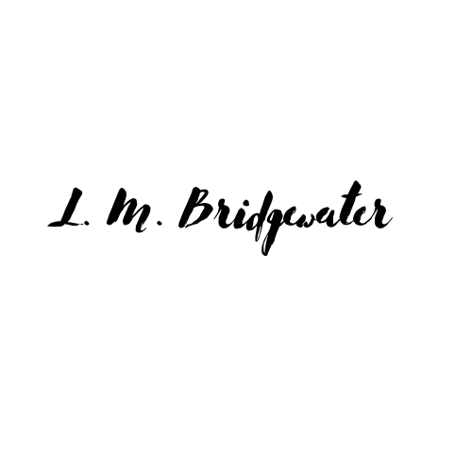

Markel Law owns the copyright in this document. You must not use this document in any way that infringes the intellectual property rights in it. You may download and print this document which you may then use, copy or reproduce for your own internal non-profit making purposes. However, under no circumstances are you permitted to use, copy or reproduce this document with a view to profit or gain. In addition, you must not sell or distribute this document to third parties who are not members of your organisation, whether for monetary payment or otherwise.
iCan Wellbeing Group CIO are members of the FSB

