Health and Safety Policy
This is the health and safety policy of:
iCan Wellbeing Group CIO

Part 1: Statement of Intent
Our health and safety policy is to, so far as is reasonably practicable:
- Prevent accidents and cases of work related ill-health.
- Manage health and safety risks in our workplace.
- Provide such information, instruction, training and supervision necessary to ensure that our employees are competent to undertake their work.
- Consult with our employees on matters of health and safety.
- Encourage all employees to engage in maintaining safe working practices.
- Provide and maintain safe plant and work equipment.
- Provide all necessary Personal Protective Equipment.
- Ensure that all substances are used, stored and handled safely.
- Maintain safe and healthy working conditions.
- Implement all necessary emergency procedures, including evacuation procedures in the event of fire or other significant incident.
- Ensure that adequate provision is made for welfare facilities and that adequate first aid provisions are made.
- Review this policy annually and revise whenever there is a change in circumstances, in work practices or the introduction of new legislation affecting the policy, so as to ensure that these standards of health and safety are maintained.

Signed: 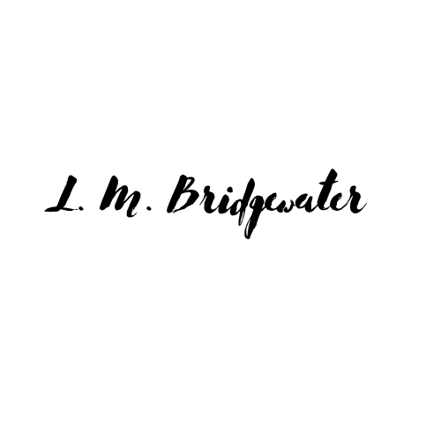
Print Name: iCan Wellbeing Group CIO
Date: 01/04/2024
Date for next review: 01/04/2025
Part 2: Responsibilities for health and safety
Overall responsibility for health and safety:
Lisa Bridgewater and Julia Clifford: Co-Chief Officers

Day-to-day responsibility for ensuring that this policy is put into practice:
Lisa Bridgewater and Julia Clifford: COO and CCO respectively

The following people have responsibilities in the following areas:
Lisa Bridgewater- Employees and sessional staff
Lisa Bridgewater and Julia Clifford- Beneficiaries

Additionally, all employees must:
• co-operate with supervisors and managers on health and safety matters;
• take reasonable care of their own health and safety; and
• report all health and safety concerns to an appropriate person (as detailed above).

Part 3: Arrangements for health and safety
The following is not an exhaustive list. You may have additional arrangements or some of these may not apply. You will need to amend the list and add the detail of your specific arrangements under the relevant headings.
- Risk Assessment
Appropriate risk assessments will be completed, kept under review and their findings implemented. We have completed the following risk assessments: venue or asset risk assessments, covid risk assessments for all venues or assets.
- Communication of policy
A copy of this policy is available in the iCan office
- Training of employees
Training shall be provided on induction and on exposure to new or increased risks, for example following the introduction of new equipment, technology or systems of work. Refresher training shall be repeated periodically. Records of all training shall be kept.
- Consultation with employees
Consultation with staff on health and safety matters will take place routinely as they arise and following any review of health and safety matters where changes are required.
- Fire Safety
A fire risk assessment has been carried out for the site and will be kept under review.

- Manual handling assessment and policy
Manual handling instructions must be followed in accordance with our manual handing procedure and training when carrying any load. Although this is uncommon.

- Selection of, provision of information to and monitoring of sub-contractors to ensure competence with reference to CDM Regulations.
Appropriate checks will be carried out to ensure sub-contractors working on site have the appropriate technical knowledge and knowledge of health and safety related to their work and to ensure their work is kept under review. Sub-contractors to provide risk assessments and method statements and evidence of their competency e.g. qualifications, training completed, references, or membership of a trade body, where applicable.

- Public safety assessment and procedures.
A risk assessment has been carried out for members of the public on site and will be kept under review. All visitors shall be given safety information, instruction and training, protective clothing or safety equipment as may be necessary.

- Evacuation & Emergency Procedures.
In the event of an emergency, the fire alarm will sound and a designated person will ensure the evacuation of all persons present on site to their assembly point, contact the emergency services when required and ensure compliance with any relevant emergency procedure.

Staff shall be informed of the emergency procedures on induction and
reminded each year. The emergency evacuation procedure will be rehearsed at least once each year.

- Accident and investigation Procedures
Where there is an accident or incident at work, an accident or incident report must be completed. Any accident at work or in connection with work (whether involving an employee, visitor or other person), must be reported immediately to the appropriate person who shall arrange for the accident to be investigated and an accident report prepared, recommending means of preventing re-occurrence where appropriate.
Where the accident or incident is of a type that needs to be reported under Reporting of Injuries, Diseases and Dangerous Occurrences Regulations 2013 (RIDDOR).

- Work equipment selection and maintenance
All work equipment provided by the employer for use at work shall be:
- suitable for the intended use;
- safe for use, maintained in a safe condition and, in certain circumstances,
- regularly inspected;
- used only by people who have received adequate information, instruction and
- training; and
- accompanied by suitable safety measures, e.g. protective devices, markings,
warnings.
All equipment used must be maintained in a safe condition and in good
repair. Where necessary, equipment shall be inspected to ensure that it is safe for use without risk of injury or damage and appropriate records shall be kept up to date.

The use of any equipment that is not owned by the employer must be authorised in advance.

- Personal Protective Equipment
Personal Protective Equipment (PPE) appropriate for the risks involved and suitable for the task and the person undertaking it will be supplied and must be used whenever there is a risk to staff’s health and safety which cannot be adequately controlled by alternative means. Where PPE is required it shall be provided at the employer’s cost and must be used by staff in accordance with any manufacturer instructions and any directions and training given. Any defects in PPE must be reported immediately on discovery.

- Hazardous substances (COSHH), assessment and control measures
In accordance with the Control of Substances Hazardous to Health Regulations 2002 (COSHH) we will:
- Undertake assessments of all work processes where substances are involved and
decide which of the processes involve the use of substances hazardous to health
so that decisions can be made about necessary control measures;
- Maintain records of all COSHH assessments;
- Inform the workforce of any findings of any assessments and provide any person
exposed to substances hazardous to health with the necessary information,
instruction and training for them to know the risks to health created by such
exposure and the precautions that should be taken;
- Review all assessments (if the work process changes significantly) and annually
from the date of the original assessment; and
- Provide suitable Personal Protective Equipment.

- Display Screen Equipment (DSE) assessment / provision

- The workstation of anyone who uses display screen equipment for a significant amount of time (two or more hours per day) will be assessed (and where necessary adapted) to ensure that its design and layout will avoid visual fatigue and back, shoulder, neck, arms, legs and wrist aches. Adequate chairs, work surfaces and equipment shall be provided.
- Periodic breaks from using the equipment are encouraged.
- On request, once a year, a voucher (or reimbursement of cost on production of a
receipt) for an eye and eyesight test by an optician will be provided. If special corrective appliances for display screen work only are required and a normal appliance cannot be used, the employer will bear the cost of a basic appliance (e.g. the least expensive frame and basic lenses).
- Where necessary, training on the safe use of display screen equipment shall be made available.

- Welfare provisions
Adequate provision will be made for welfare facilities at all sites.

- First aid provisions
Adequately stocked first aid boxes will be kept on site. All First Aiders shall receive first aid training, attend refresher courses, pass all the necessary qualifications and hold a current First Aid at Work certificate.

Please note – this document was provided and supported by Markel Law through the Federation of small buisnesses on which iCan Wellbeing Group CIO is a member.

